 | Day 1: Friday, September 15, 2023
TIMES | SESSION AND SPEAKER | CEU | LOCATION
 | MORNING SCHEDULE
7:30am-8:30am | Attendee registration and Exhibitor set-up |  | Foyer
8:30am-8:45am | Welcome Address  Michele Cramer, AuD, LAA President |  | Lafitte A & B
8:45 am-9:30am | LAA Membership Meeting and Elections  Michele Cramer, AuD, LAA President |  | Lafitte A & B
9:30am-10:00am | BREAK with Exhibitors/Coffee |  | D. H. Holmes 1-3
10:00am-11:00am | Music and Hearing Aids  Dr. Marshall Chasin, AuD | .10 | Lafitte A & B
 | AFTERNOON SCHEDULE
11:00am-12:00pm | BREAK with Exhibitors/Grab Your Lunch |  | D. H. Holmes 1-3
12:00pm-1:00pm | Platinum Exhibitor’s Round Table Technology Discussion | .10 | Lafitte A & B
1:00pm-1:30pm | BREAK with Exhibitors/Refreshments |  | D. H. Holmes 1-3
1:30pm-3:30pm | Musicians and the Prevention of Hearing Loss  Dr. Marshall Chasin, AuD Tier 1 | .20 | Lafitte A & B
3:00pm-3:30pm | BREAK with Exhibitors/Refreshments |  | D. H. Holmes 1-3
3:30pm-5:30pm | Cognition, Audition and Amplification  Doug Beck, AuD, CCC-A, F-AAA Tier 1 | .20 | Lafitte A & B
6:00pm-7:00pm | 8th Annual LAA Reception, Awards, & Silent Auction |  | D. H. Holmes 1-3
7:00pm-10:30pm | 4th Annual LAA Evening Dinner & Entertainment |  | Lafitte A & B
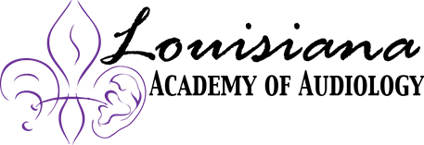

Join our exhibitors and speakers for a Fun Night Under the Big Top themed event! One room will be set up for those that want to eat, drink and dance. For those that like to play dress up, the costume party will have prizes, meet, and greet, and dinner dance. Appetizers and cash bar available, and we will also encourage you to participate in our live auction where the proceeds will go towards the LAA Foundation Fund and the FLASC. At the reception, we will announce and honor our “LAA Achievement Award in Audiology” honoree at the “Lynn Creel Happy Hour” Reception.
 | Day 2: Saturday, September 16, 2023
TIMES | SESSION AND SPEAKER | CEU | LOCATION
 | MORNING SCHEDULE
7:30am-8:00am | Attendee registration |  | Foyer
8:00am-9:00am | Well Hearing is Well Being  Cheri Hebeisen, AuD, CCC-A | .10 | Lafitte A & B
9:00am-10:00 | Speech in Noise: How and Why  Doug Beck, AuD, CCC-A, F-AAA | .10 | Lafitte A & B
10:00am-10:30am | BREAK with Exhibitors/Coffee |  | D. H. Holmes 1-3
10:30am-11:30am | The Ups and Downs of Medicare Advantage Programs:  What Should My Clinic Do?  Dan Quall, MS, CCC-A | .10 | Lafitte A & B
11:30am-12:00pm | BREAK with Exhibitors/Bloody Mary’s and Mimosas  Exhibit Hall Open |  | D. H. Holmes 1-3
 | AFTERNOON SCHEDULE
12:00pm-1:00pm | Ethics, What’s in Your Toolbox?  Steve Madix, PhD | .10 | Lafitte A & B
1:00 pm | Adjourn and Have Fun on Bourbon Street | 10

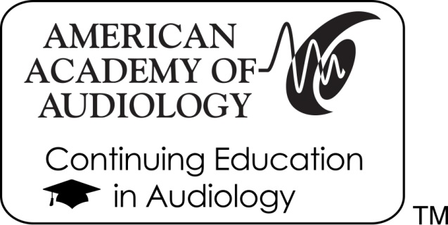
The Louisiana Academy of Audiology is approved by the American Academy of Audiology to offer Academy CEUs for this activity. The program is worth a maximum of 1.0 CEUs (10 hours). Academy approval of this continuing education activity is based on course content only and does not imply endorsement of course content, specific products, or clinical procedure, or adherence of the event to the Academy's Code of Ethics. Any views that are presented are those of the presenter/CE Provider and not necessarily of the American Academy of Audiology.
SAVE THE DATE FOR THE NEXT LOUISIANA ACADEMY OF AUDIOLOGY CONFERENCE:
September 19-21, 2024

